**LAB # 01 and Lab# 2**

**Introduction to the UNIX and UNIX Filesystem**



Spring 2022

Operating system

Submitted by:

**Maaz Habib**

Class Section:

**C**

“On my honor, as student of University of Engineering and Technology, I have neither given nor received unauthorized assistance on this academic work.”

Submitted to:

**Ibad**

April 15th, 2022

Department of Computer Systems Engineering

University of Engineering and Technology, Peshawar

**Questions:**

**PART 1:**

**(All questions refer to Figure I as the file structure)**

**2) If you are logged into DCSE and you want to go to your TA's home directory, how would you do it without knowing anything about the DSCE departments file structure? (Your TA's username is torfanos)**

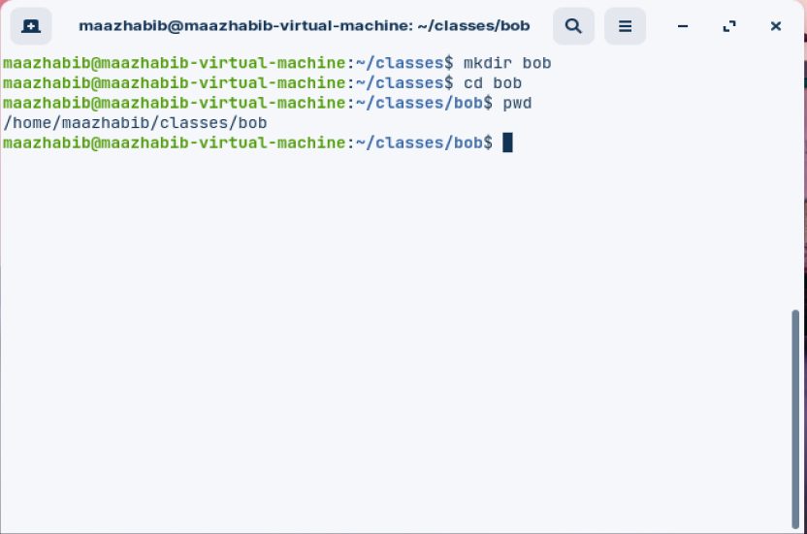

**PART 3:**

**Questions:**

**These questions are based on a directory which has the following files in it: file1 file2 file3 file4 afile file.c file.s file.so file.o farm.c farm.co**

**NOTE: All expansion solutions should be of the format command file(s). There should only be one argument following command and in order to get multiple files you must use wildcards.**

1. **How would you list files these files (file2, file3, file4)? (HINT use ls)**

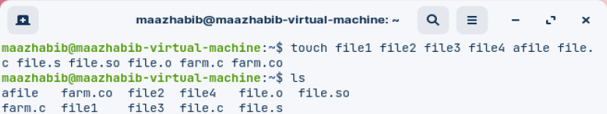

1. **How would you remove, using the rm file(s) command, file.c and file.s (note: keep file.o)?**

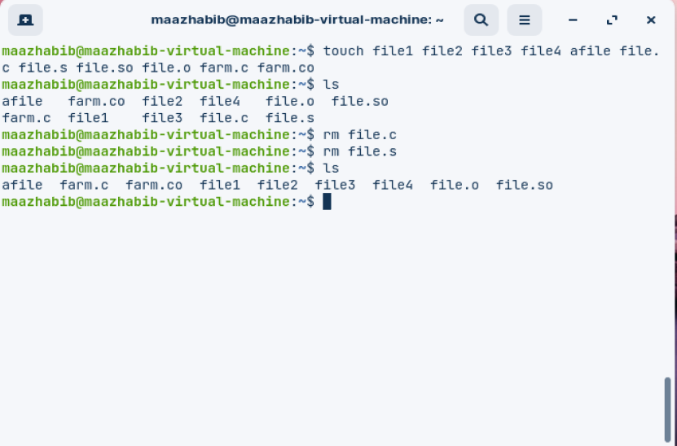

1. **How would you remove any file which contains the word file in it?**

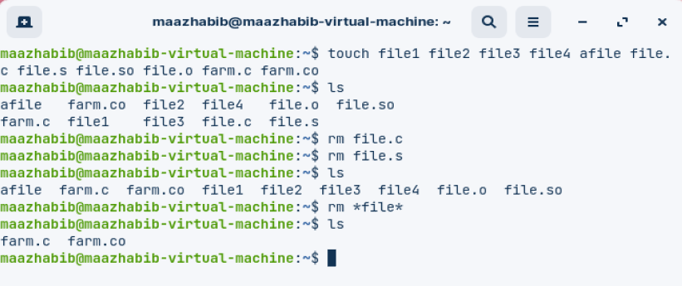

1. **How would you list all files that begin with f and end with a 2 letter suffix.**

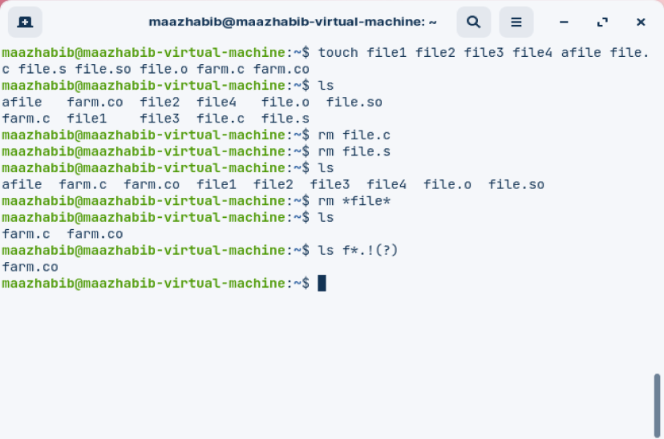

1. **If you had a file which was called hard? with ? actually being a question mark. How would you reference that file?**

